NAME: LAURA BINFA NANJI
DEPARTMENT: COMPUTER SCIENCE
INSTITUTION: UNIVERISTY OF JOS
PROJECT TITLE: WEEK 2 PROJECT

TASK 1: System Information
USERNAME: kali
HOSTNAME: kali
WORKING DIRECTORY: /home/kali
LINUX VERSION: KALI LINUX 2025.4
HOME DIRECTORY: /home/kali
SHELL: /usr/bin/zsh
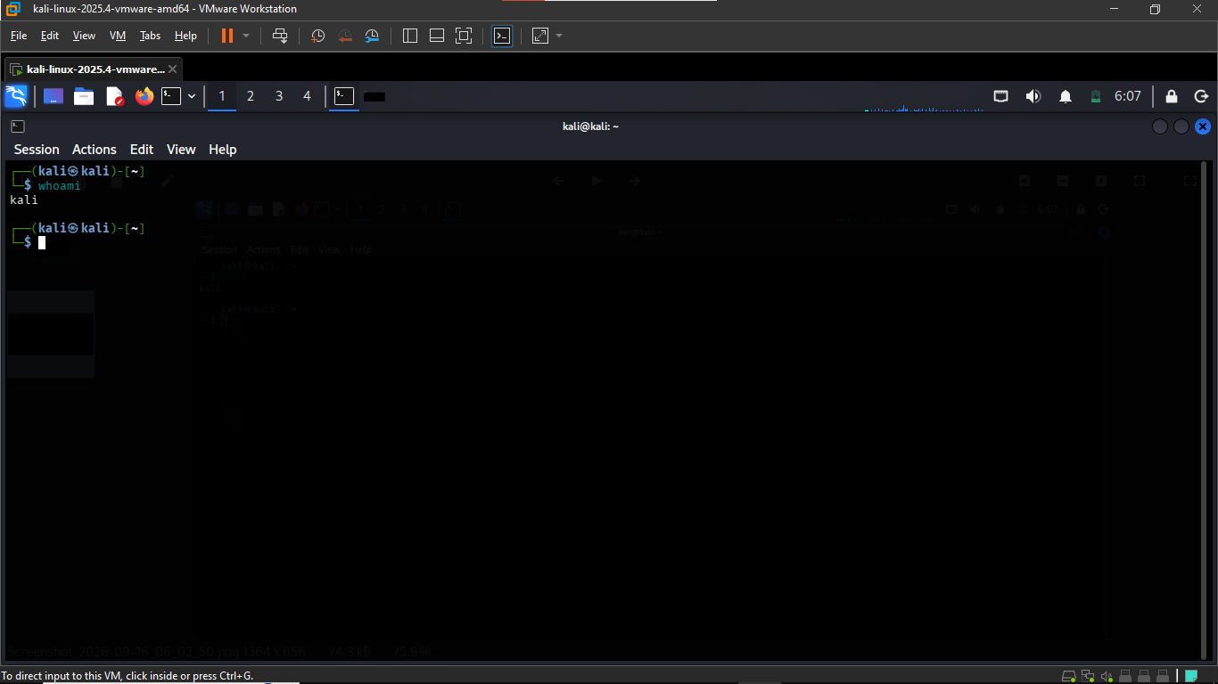
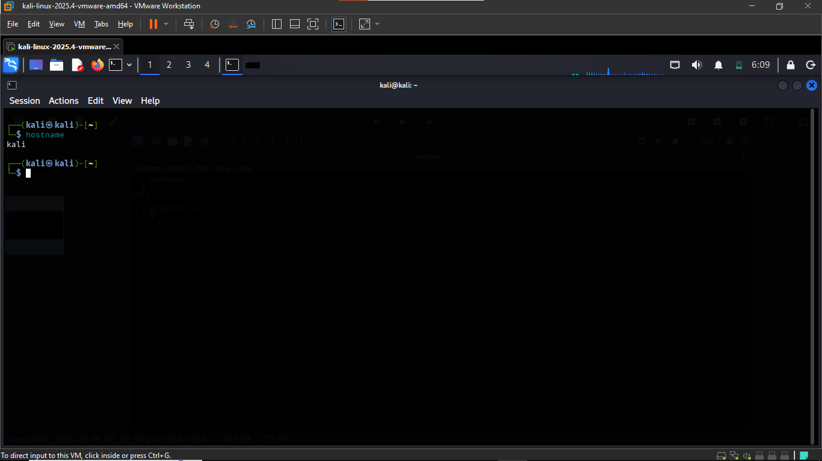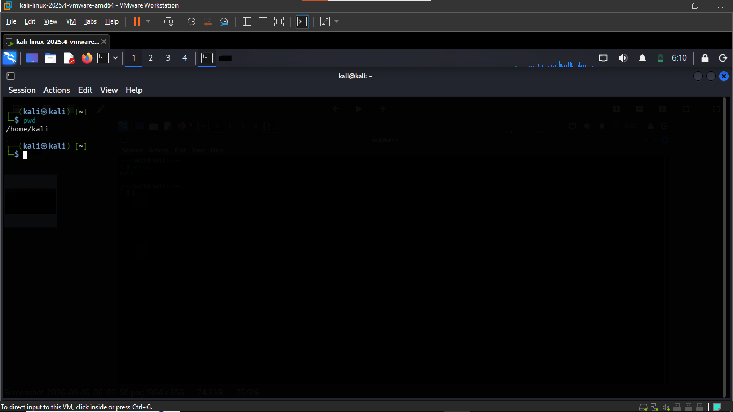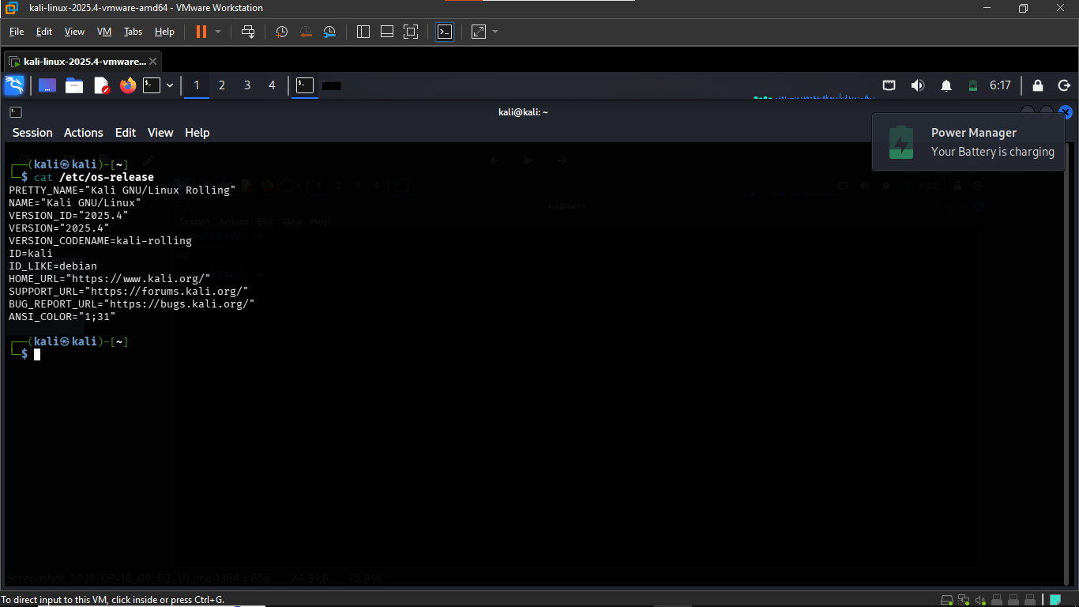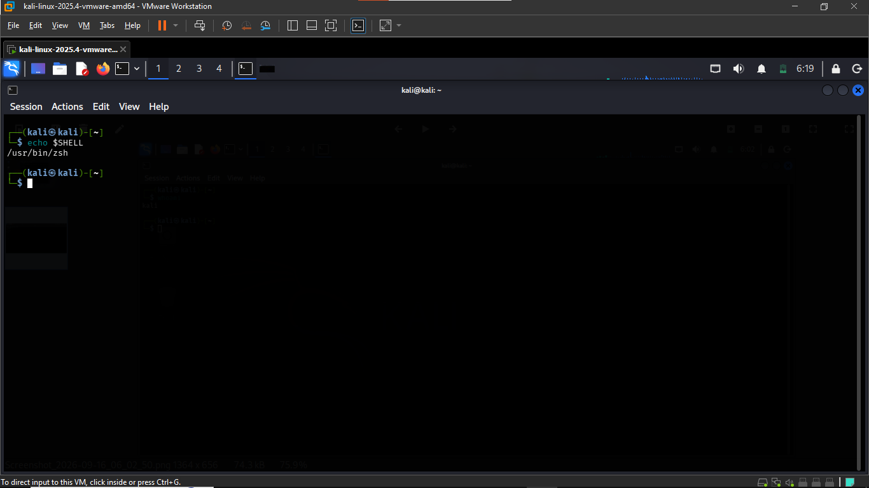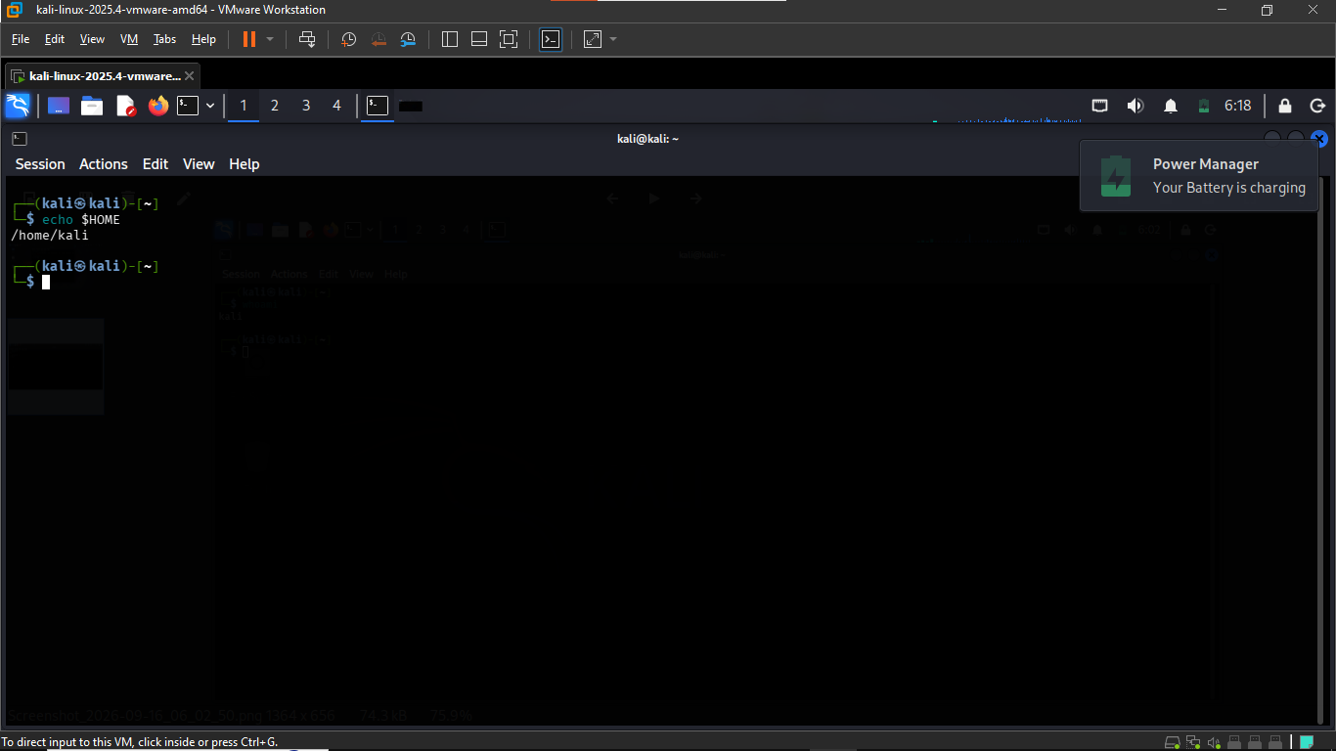

TASK 2: File and Directory
In this task, core Linux file operations were executed to manage directory structures and files:
- mkdir: Created a new target directory (Lab)
- touch: Generated a new blank text file (laura.txt)
- cp: Copied laura.txt into notes.txt
- mv: Renamed notes2.txt to notes3.txt
- ls -la: Displayed detailed directory contents and file permissions to verify all changes
- cd: Entered an existing directory SIWES-LAB
- cat: Read out contents of laura.txt
- rm: Removed text file notes3.txt
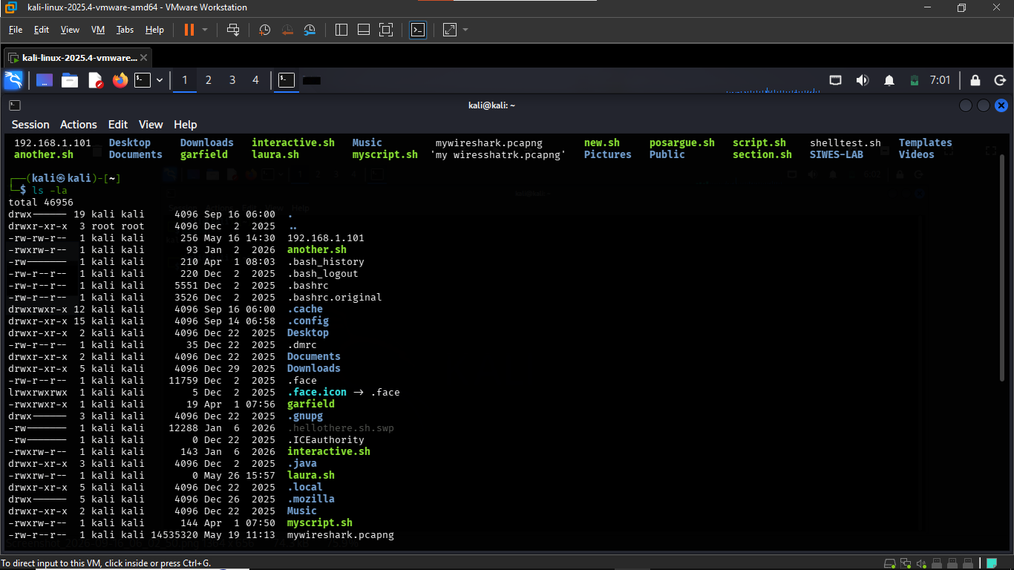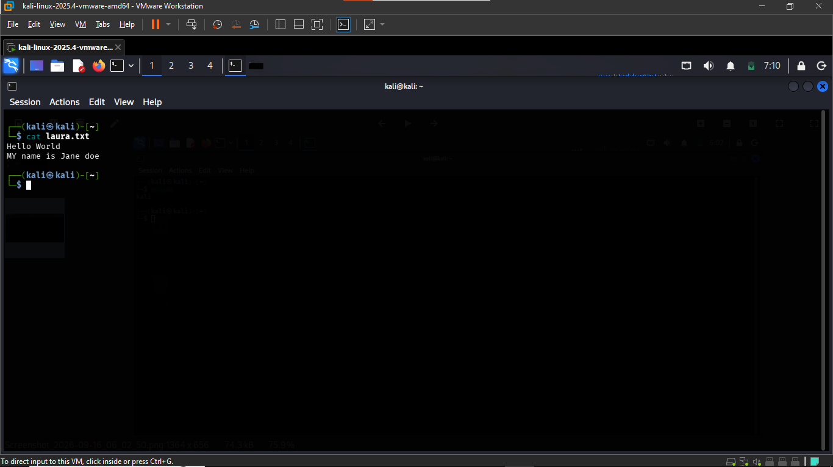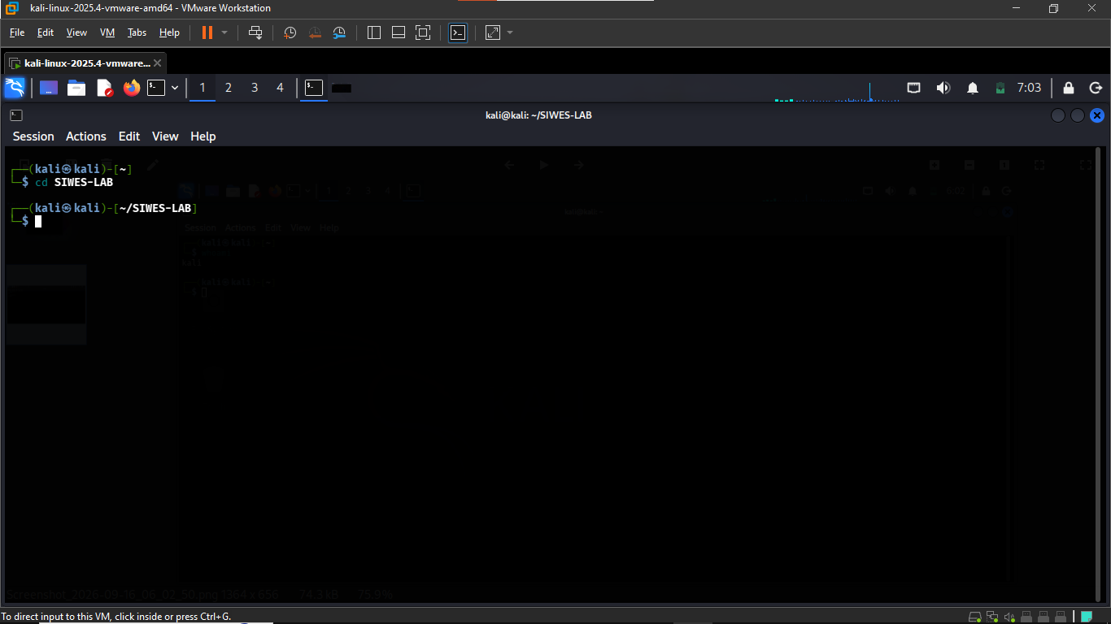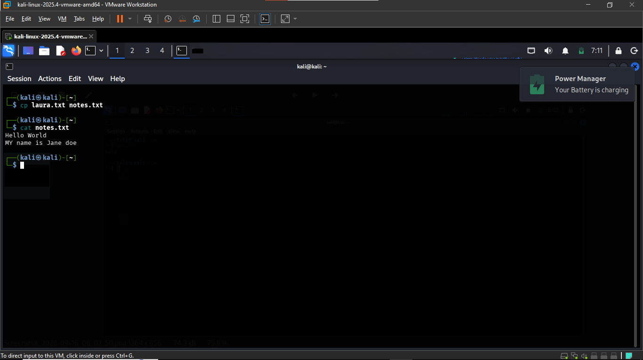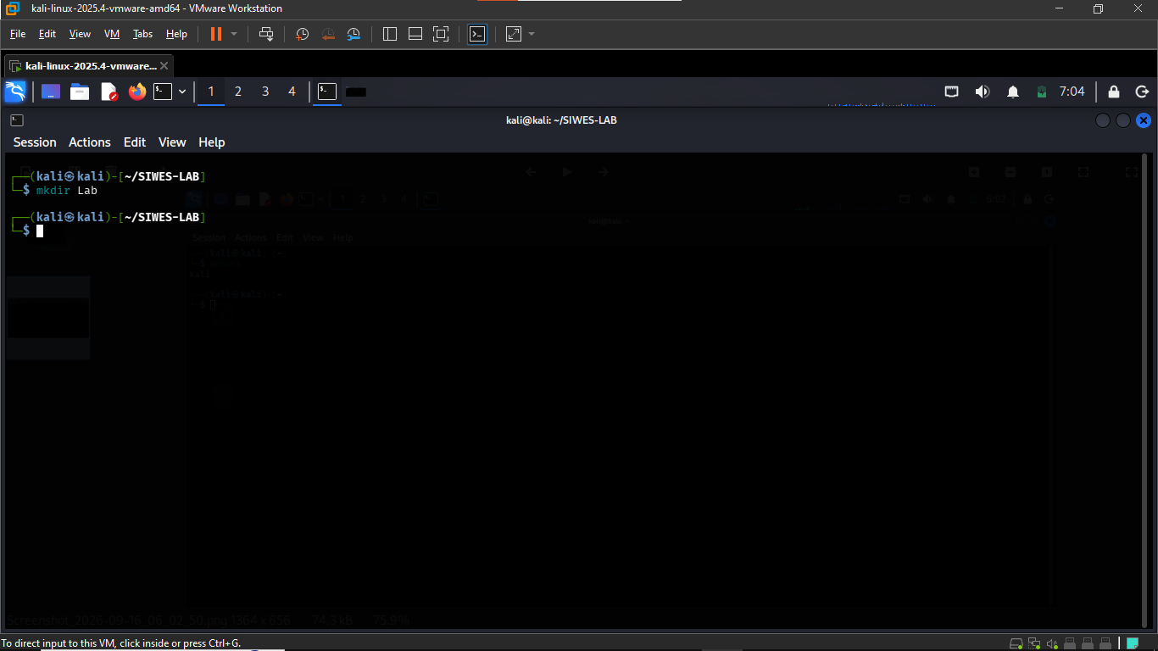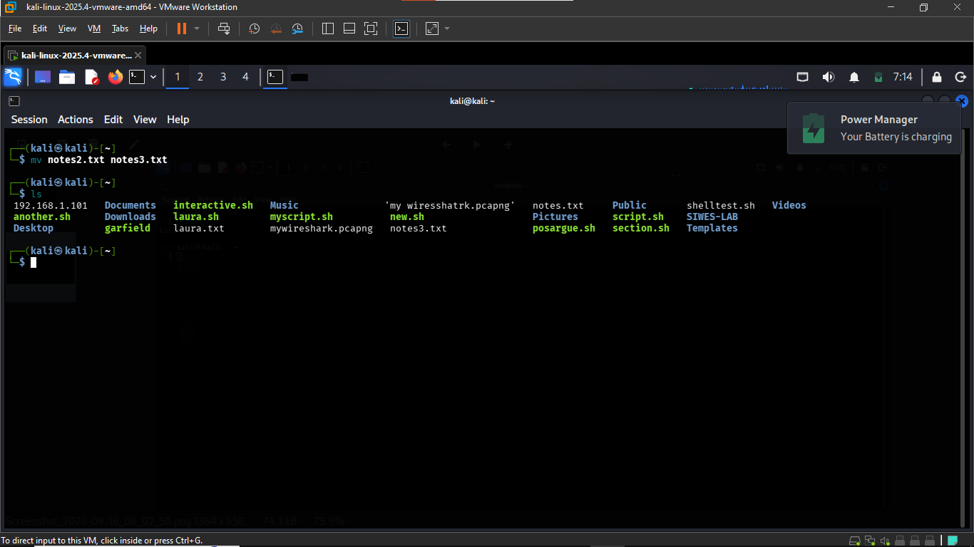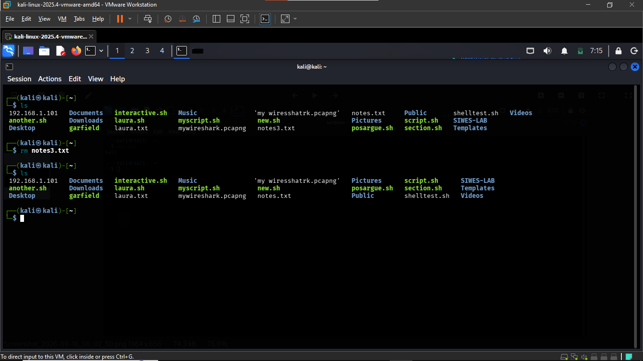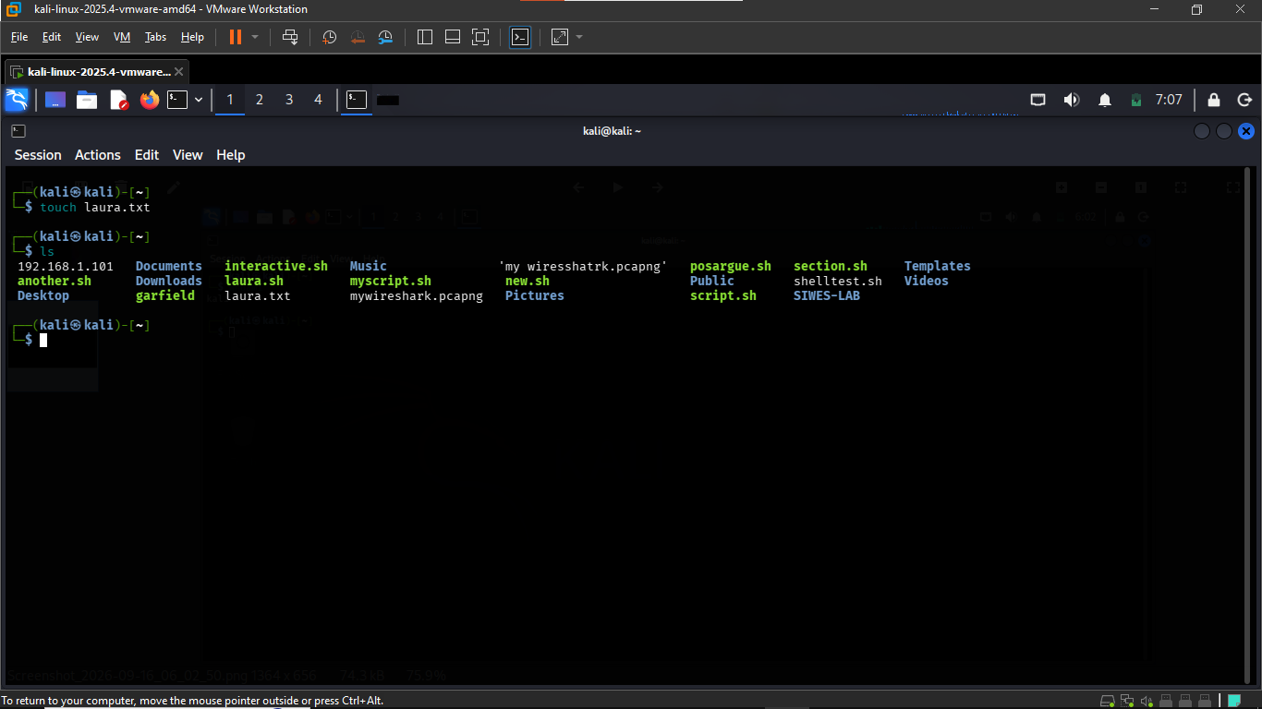

TASK 3: Users, Groups and Permissions
- The whoami command was used to identify the current user. The result showed that the current user is kali.
- The id command was then used to display the user ID and group information associated with the account. The groups command was also used to display the groups to which the user belongs.
- Three test files were created using the following command:
touch public.txt private.txt script.sh
The files created were: public.txt , private.txt and script.sh
- The following permissions were applied to the files:
chmod 644 public.txt
chmod 600 private.txt
chmod 755 script.sh
The ls -l command was used to verify the resulting file permissions.
- Linux file permissions determine who can read, modify, or execute a file.
Read (r): Allows the contents of a file to be viewed.
Write (w): Allows the contents of a file to be modified.
Execute (x): Allows a file to be executed when it is a program or script.
The permission 644 on public.txt gives the owner read and write permissions, while the group and other users have read permission.
The permission 600 on private.txt gives the owner read and write permissions, while the group and other users have no permissions.
The permission 755 on script.sh gives the owner read, write, and execute permissions, while the group and other users have read and execute permissions.
These permissions demonstrate how Linux controls access to files and helps protect information from unauthorized modification or access.

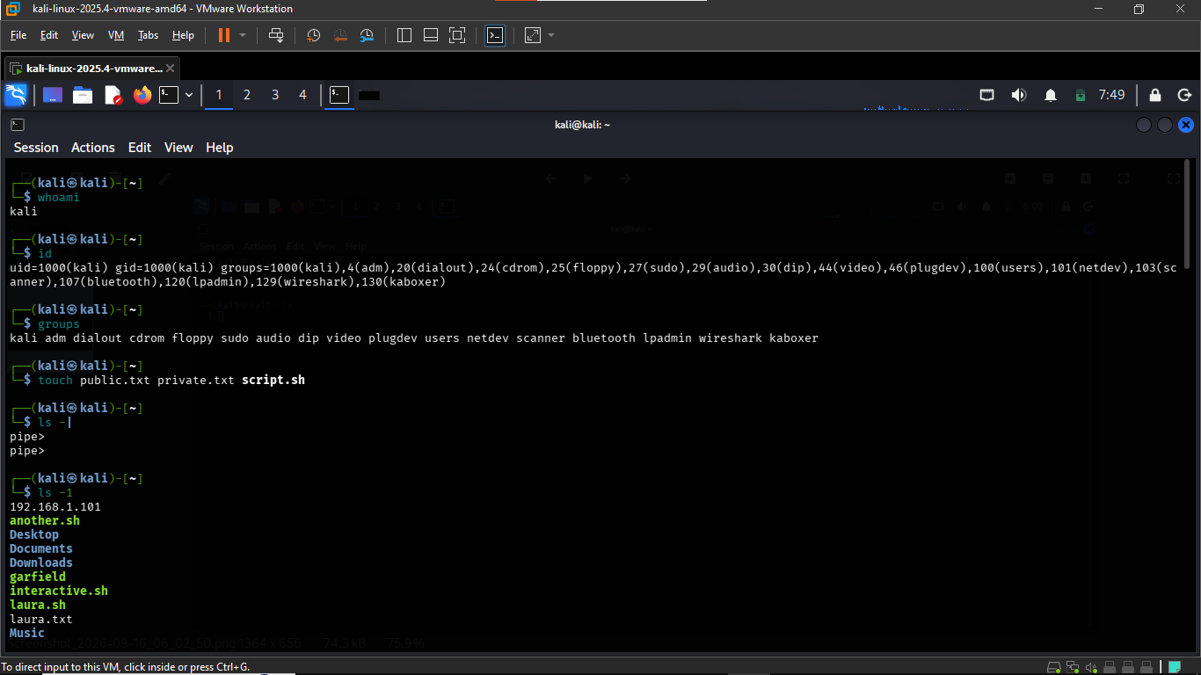
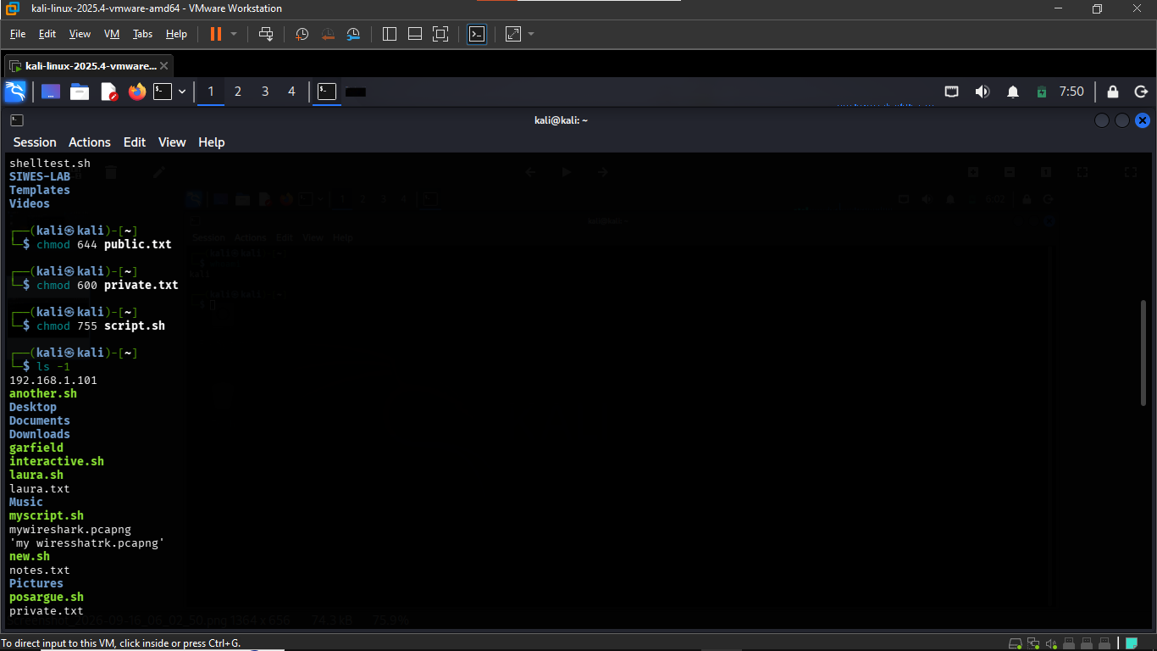

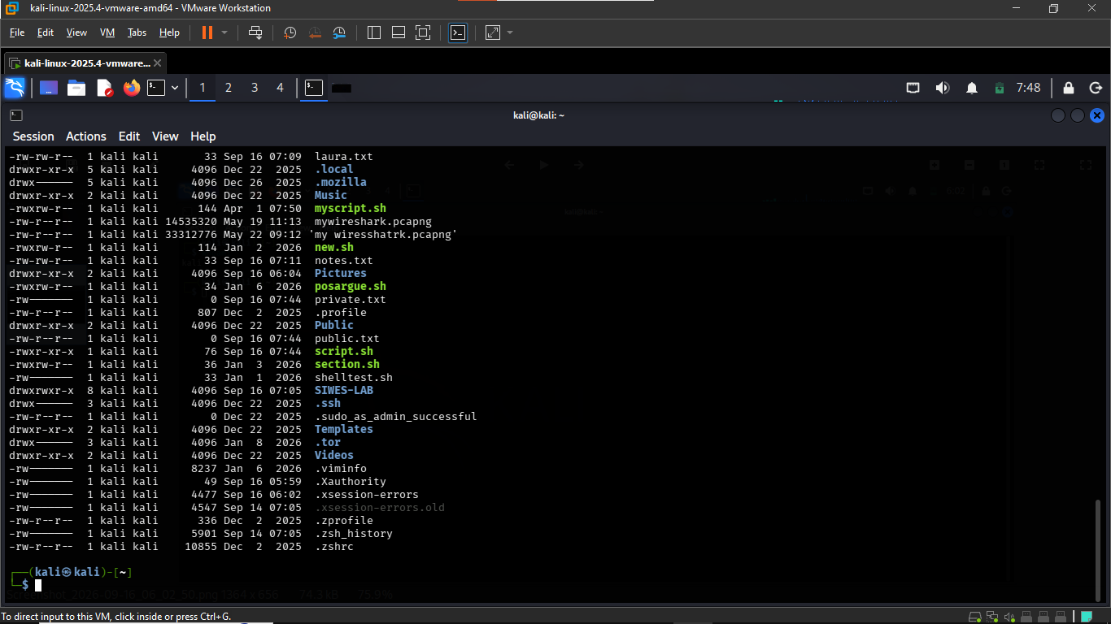

TASK 4: Process Investigation
The running processes on the Kali Linux workstation were inspected using the ps, ps aux, and top commands. These commands were used to view active processes, their process IDs (PIDs), owners, and other process information.

Five running processes identified from the system were:
Process Name | PID | Owner
upowerd | 1564 | root
Xorg | 978 | root
dbus-daemon | 506 | message+
xfwm4 | 1460 | kali
qterminal | 2304 | kali

Purpose of Selected Processes:
Xorg:
Xorg is a process associated with the graphical display system of the workstation. It supports the graphical interface used by the desktop environment.
qterminal:
qterminal is the terminal application running on the graphical desktop. It allows the user to enter and execute Linux commands.
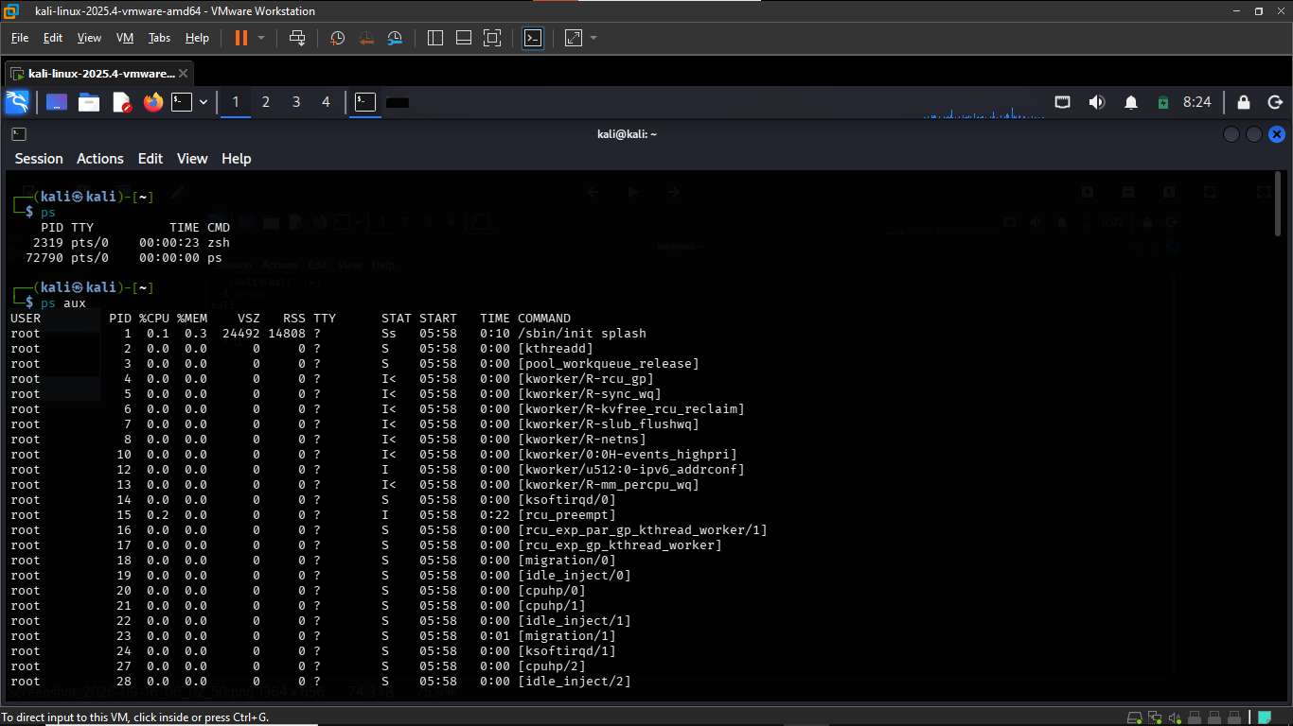
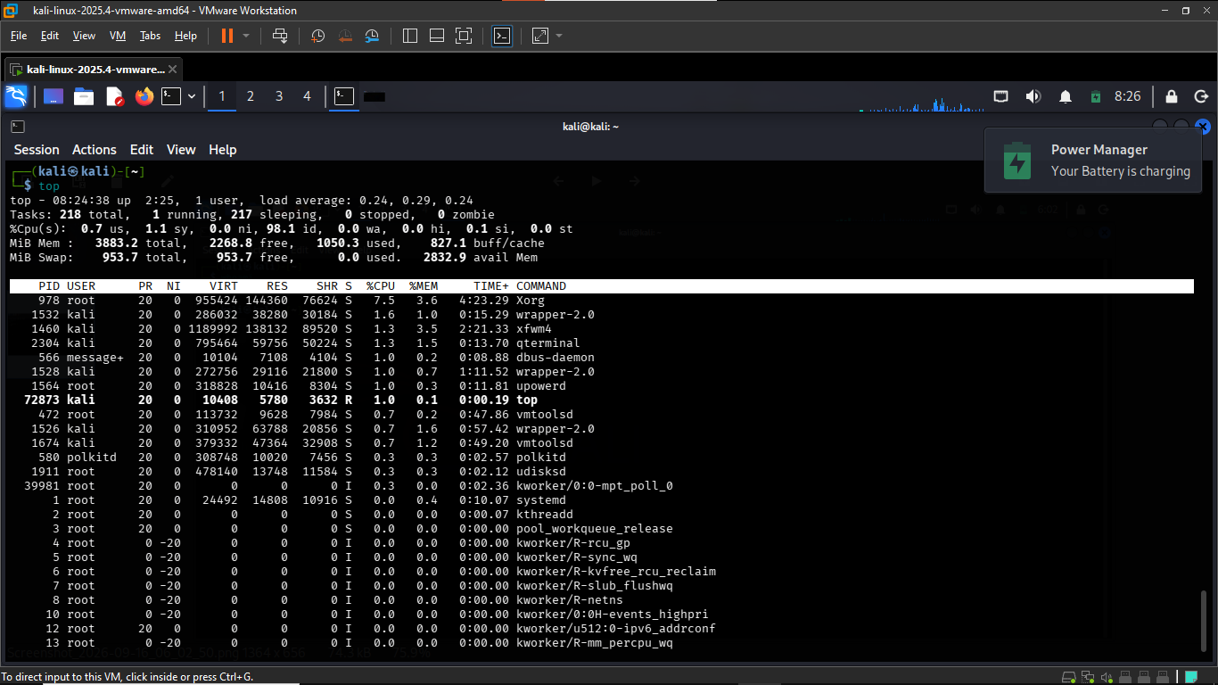

TASK 5: Service investigation
The systemctl --type=service command was used to inspect the services currently running on the Kali Linux workstation. Three services shown as active(running) were selected for investigation:
Service | Status | Purpose | May communicate over the network
lightdm.service | Active(running) | Light display manager provides graphical login screen and manages graphical user sessions. | No, not normally a network service.
NetworkManager.service |  | Network Manager manages network interfaces and network connections on the system. | Yes. It is directly involved in managing network connectivity.
systemd-timesyncd.service |  | Provides Network time synchronization to keep the system clock accurate. | Yes, it can communicate with network time servers.

The investigation shows that some active services may communicate over a network, while other primarily provide local system functions. Identifying active service’s is useful when investigating the services running on Linux workstation.

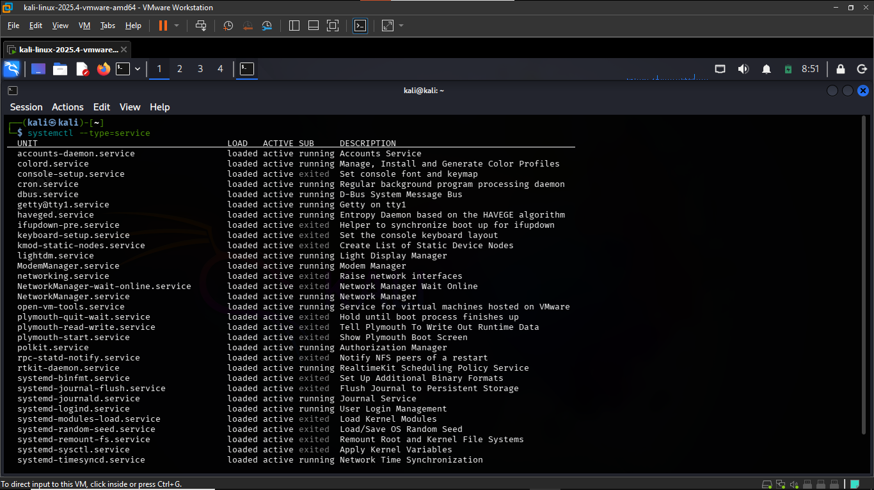

TASK 6: Environment Variables
- The USER variable identifies the current user account
- The HOME variable identifies the user’s home directory
- The SHELL variable identifies the command line shell being used.
- The PATH variable contains a list of directories that the shell searches when a command is entered. This allows commands and programs to be executed without entering their complete file paths.

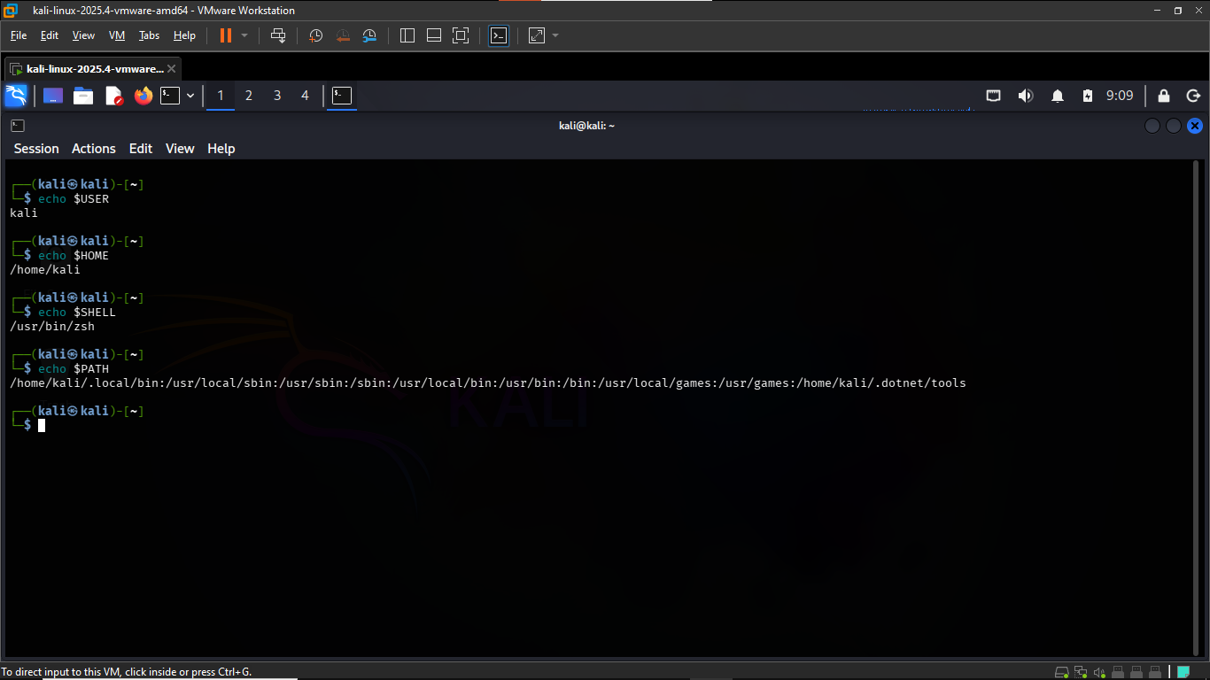

TASK 7: Filesystem and Log exploration

The following Linux filesystem locations were explored: /home, /etc, /var, /var/log, /tmp, /usr, and /proc. The purpose of each directory is described below.
- /home:
Contains the personal home directories and files belonging to users.
- /etc:
Contains system configuration files used to configure Linux and its services.
- /var:
Contains variable data that changes during normal system operation, such as logs and other system data.
- /var/log:
Contains system and application log files that can be used for monitoring and investigation.
- /tmp:
Contains temporary files used by the system and applications.
- /usr:
Contains many user programs, utilities, libraries and other shared system resources.
- /proc:
Provides information about running processes and other kernel and system information.

The /var/log directory was located and inspected as part of the filesystem exploration. This directory is important during security monitoring and incident investigation because it contains system and application log information
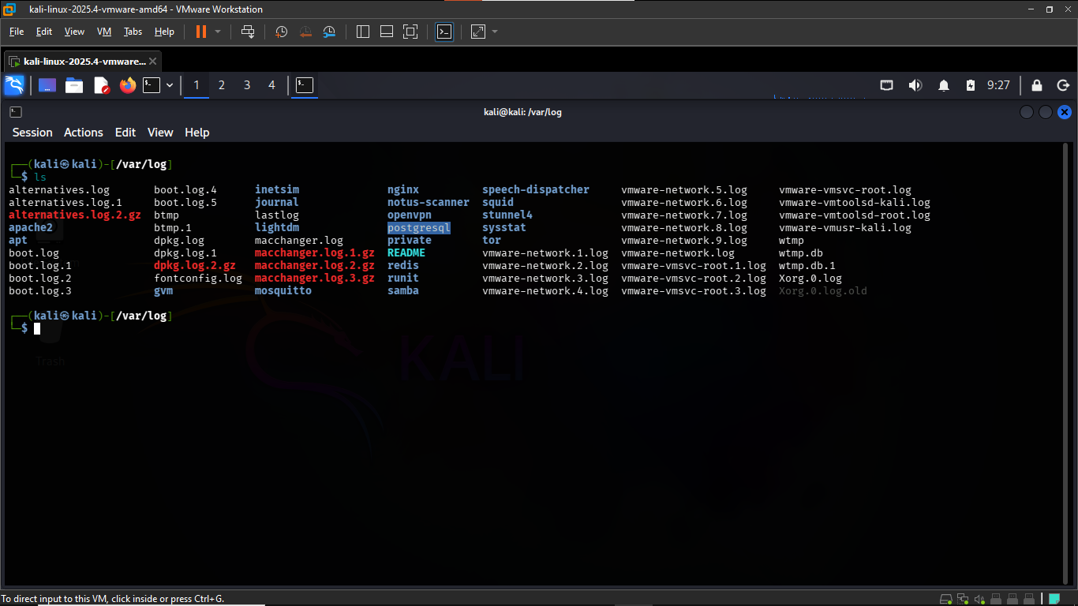

TASK 8: Search and inspection
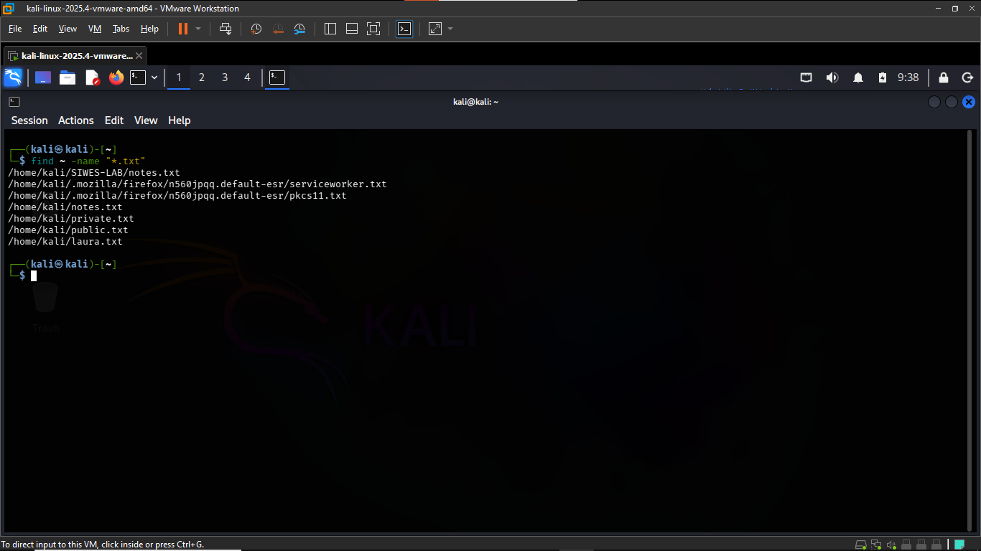
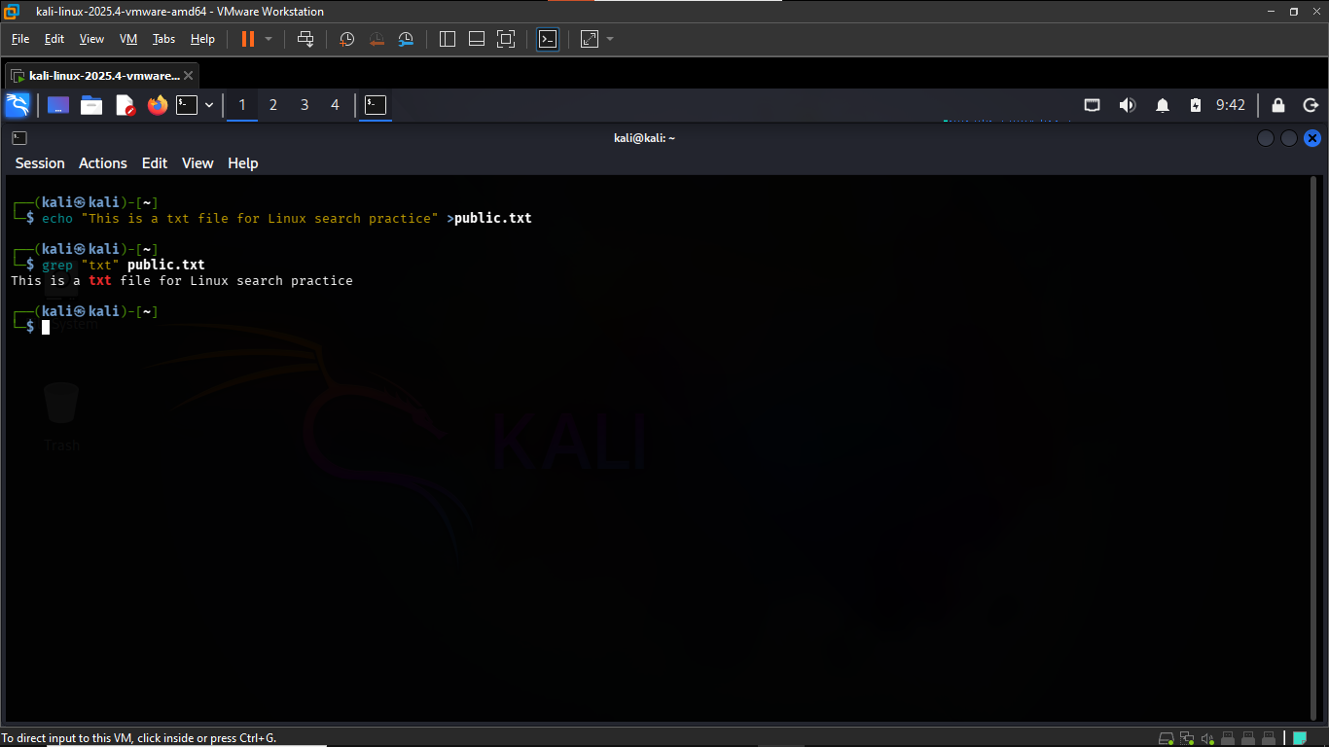

Security Observations and Reflection:
1. Why is the principle of least privilege important?
The principle of least privilege is important because users and programs should only have the permissions they need to perform their required tasks. This reduces the risk of unauthorized access, accidental changes, or damage to important files and system resources.
2. Why is it risky to use the root or administrator account for ordinary work?
Using the root or administrator account for ordinary work is risky because it has extensive privileges. A mistake or malicious command executed with these privileges could affect important system files or settings. Using a normal user account helps reduce this risk.
3. Why are file permissions important in cybersecurity?
File permissions are important because they control who can read, write, or execute files. Correct permissions help prevent unauthorized users from accessing or modifying information. During Task 3, permissions such as 644, 600, and 755 were applied to demonstrate different levels of access.
4. Why do security analysts inspect running processes?
Security analysts inspect running processes to understand what programs are currently active on a system. This can help them identify normal system activity and investigate processes that may require further attention.
5. How can unnecessary services increase a system's attack surface?
Unnecessary services can increase a system's attack surface because active services may provide additional functions or network-accessible points that could potentially be targeted. Disabling unnecessary services can therefore reduce the number of components that need to be monitored and protected.
6. Why are system logs useful during security monitoring or incident investigation?
System logs are useful because they record information about system and application activity. Security analysts can inspect logs to help understand what happened on a system and investigate unusual or potentially significant events.
7. Which Linux command did you find most useful this week, and why?
The Linux command I found most useful was ls -la because it allowed me to view files and directories together with detailed information such as permissions and ownership. This was useful when checking the files, I created and the permissions applied to them.

Conclusion
This project provided practical experience with the basic components of a Linux workstation. I collected system information, managed files and directories, examined users and groups, applied file permissions, investigated processes and services, examined environment variables, explored important filesystem locations, and used commands to search for files and text.
The activities helped me understand how the Linux systems are organized and how basic system information can be useful when monitoring and protecting a workstation. The project also demonstrated the importance of permissions, processes, services and system logs in cybersecurity.

